(1)

> **eccdifa:=diff(y(x),x)=2*x*(1+y(x)^2);**



> **sola:=dsolve(eccdifa,y(x));**



> **ya:=unapply(rhs(sola),x,_C1);**



> **plot([ya(x,1),ya(x,2),ya(x,3)],x=-10..10,y=-10..10);**

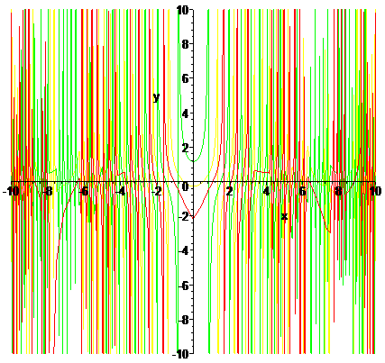

> **eccdifb:=(x^2-1)*diff(y(x),x)+2*x*y(x)^2=0;**



> **solb:=dsolve(eccdifb,y(x));**



> **yb:=unapply(rhs(solb),x,_C1);**



> **plot([yb(x,1),yb(x,2),yb(x,3)],x=1..3,y=-10..10);**

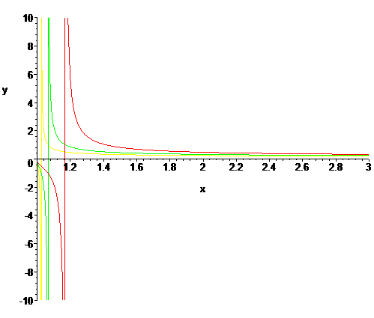

> **eccdifc:=2*x^2*diff(y(x),x)=x^2+y(x)^2;**



> **solc:=dsolve(eccdifc,y(x));**



> **yc:=unapply(rhs(solc),x,_C1);**



> **plot([yc(x,1),yc(x,2),yc(x,3)],x=0..3,y=-10..10);**

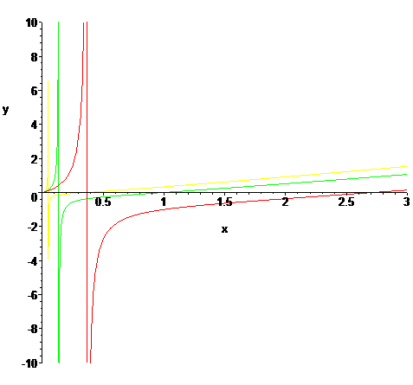

> **eccdifd:=diff(y(x),x)=-x/y(x);**



> **sold:=dsolve(eccdifd,y(x),implicit);**



> **yd:=unapply(subs(y(x)=y,lhs(sold)),x,y,_C1);**



> **implicitplot(yd(x,y,0)=1,x=-1..1,y=-5..5);**

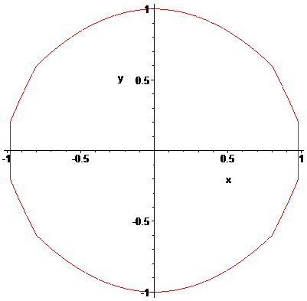

> **eccdife:=diff(y(x),x)=-x/y(x)^3;**



> **sole:=dsolve(eccdife,y(x),implicit);**



> **ye:=unapply(subs(y(x)=y,lhs(sole)),x,y,_C1);**



> **implicitplot(ye(x,y,0)=1,x=-5..5,y=-5..5);**

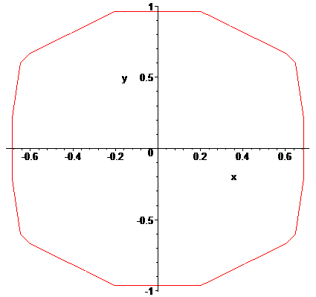

> **eccdiff:=diff(y(x),x)=-(x+y(x))/y(x);**



> **solf:=dsolve(eccdiff,y(x));**



> **yf:=unapply(subs(y(x)=y,lhs(solf)),x,y,_C1);**



> **implicitplot(yf(x,y,0)=0,x=-5..5,y=-5..5);**

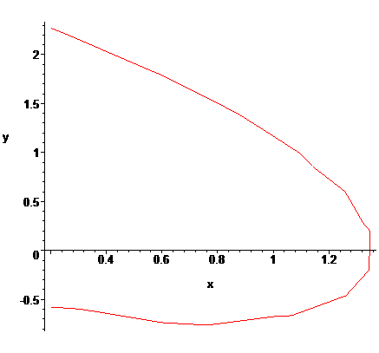

> **eccdifg:=diff(y(x),x)+y(x)*tan(x)=1/cos(x);**



> **solg:=dsolve(eccdifg,y(x));**



> **yg:=unapply(rhs(solg),x,_C1);**



> **plot([yg(x,1),yg(x,2),yg(x,3)],x=-10..10,y=-5..5);**

